

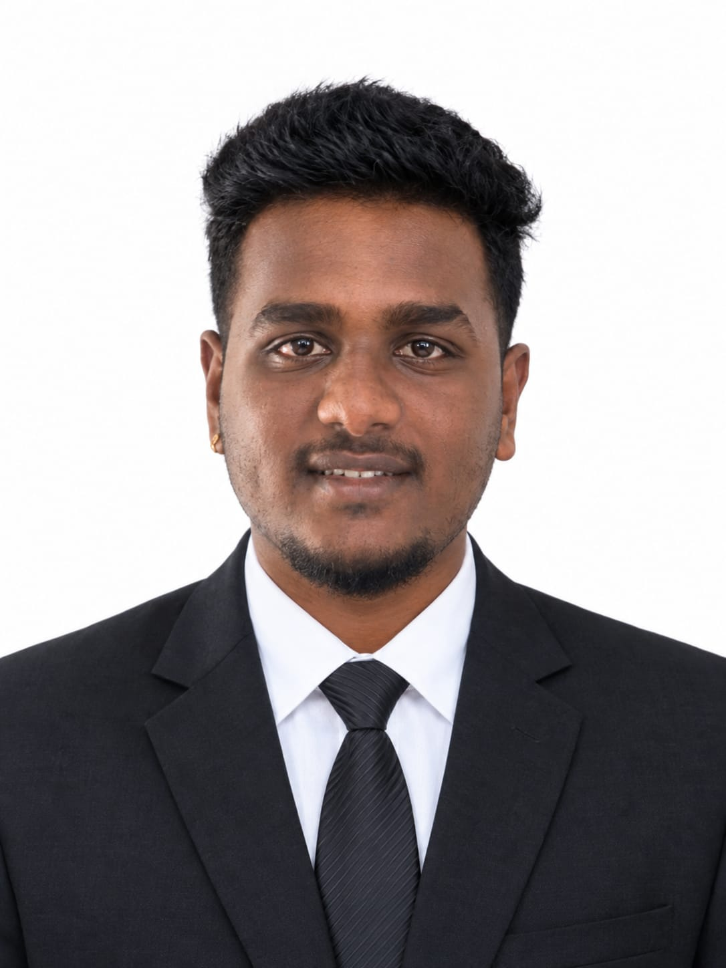

Education
Diploma in Computer science & Engineering
Hindustan Electronics Academy,

SSLC (10th)
BGS Friends English High school,
State Board,
2024

Skills

- Coding
- SQL
- Microsoft Office
- Spreadsheets

+91 6364759249

nithinofficial@gmail.com

Contact

NITHIN SAI

CAREER OBJECTIVE

To begin my career in a reputed organization where I can apply my skills and knowledge gained during my diploma and grow professionally.

TECHNICAL SKILLS
- Basic knowledge of Software Tools
- Knowledge of Computer Network, Computer Hardware & Maintenance Application
- MS Office Word, Excel, PowerPoint
- HTML

CERTIFICATIONS
- MySql
- CyberSecurity

EXTRA-CURRICULAR ACTIVITIES
- Member of IIC (Innovative Institution Council)

PERSONAL PROFILE
- Father Name: Srinivash V
- Date of Birth: 12th of February 2007
- Gender: Male
- Language known: English, Kannada, Hindi, Telugu, Tamil, Malayam.
- Nationality: Indian.
- Hobbies: Dancing, Badminton.
DECLARATION
I hereby declare that the above-mentioned information is true and correct to the
best of my knowledge and belief.

Date: 09/09/2026 Signature
Place: Bangalore Nithin Sai

